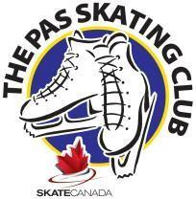
The Pas Skating Club
2023 - 2024

Parent and Me Program

The Parent and Me Program is an introductory program that allows parents to take their 2-4 year old on the ice to participate in a learn-to-skate program with guidance from a Skate Canada certified coach. Its purpose is to provide an opportunity for young children to start skating at an age where parent participation will benefit both the skater and the coach in developing the lifelong skill of skating! Children in Parent and Me must wear hockey skates or figure skates and a helmet (CSA-approved hockey helmet). Both the Parent and the Skater must register and each will pay the Skate Canada Insurance fee. The program fee is only charged to the child’s registration.

Location:  Schedule: | RHJ Arena
Monday | 5:15 pm – 5:45 pm
Start Date: | October 16, 2023
End Date: | *April 14, 2024
Year-End Review: *April 14, 2024
*Dates and times subject to change

A monthly calendar will be available on The Pas Skating Club’s bulletin board located in the Arena hallway , on Website Page, and Parent Facebook Group
Schedule is subject to change. Please check The Pas Skating Club bulletin board at the rink for updated changes, or the Club website.

www.skatethepas.uplifterinc.com

Skate Canada Professional Coach: Sherry Hunter

Cost: $96 program + $58.70 Skate Canada Insurance (Child)=$154.70 plus Skate Canada Insurance (Parent) $58.70=$213.40 *any additional parent/guardian on the ice will need to register and pay SCI fee.

